SW Engineering CSC 648/848

GatorAid: Event Discovery Web Application

Section 6 Team 6

Team Members:

Emely Sarceno Bravo – Team Lead

David Gomez – Front-End Lead

Emerson Berido – Scrum Master

Kelsey Codilla – Back-End Lead

Tavasya Ganpati – GitHub Master

Phong Nguyen – AI Lead

Milestone 3

November 11, 2026

Functionality Feedback

Instructor’s Comments on the Demo
- Improvements with Niantic 3D Scans: The instructor suggested improving the quality and detail of our existing Niantic scans while expanding the number of campus locations available. The scans should provide clearer and more accurate representations of campus buildings and individual rooms. This would help users better visualize event locations and become more familiar with the campus environment.
- Improvements with AI Assistant/Scanner: The instructor recommended further improving our AI Assistant and AI Schedule Scanner to make them more effective and user-friendly. This includes improving the accuracy of the AI-generated responses and schedule scanning results, as well as increasing speed and overall performance. Reducing loading times and making the AI features more responsive would create a smoother experience for users.
- More Sophisticated Features: The instructor encouraged us to incorporate more advanced and interactive features to make our platform stand out and explore additional use cases. This includes thinking about how different types of users, such as students, event organizers, and campus organizations, would interact with the platform and benefit from its features. We should also consider ways to make the application more interactive and connected by improving how users discover events, engage with other attendees, and navigate campus spaces. Overall, the goal is to create a more complete platform that offers a variety of useful experiences rather than simply serving as an event listing page.

Team’s Action Plan Based on Feedback
Our team plans on creating better Niantic scans and improving their overall quality so that users can get a clear and detailed view of the different rooms within campus buildings. We will try different methods recommended by the instructor and TA to improve scan quality over larger areas. We will expand the number of scans available to cover more campus locations and ensure that users can easily navigate and identify event locations.
We also plan to improve the AI Assistant and AI Schedule Scanner by making them more accurate, responsive, and efficient. We want to improve the speed and overall performance of both AI features to reduce loading times and provide users with faster results. The AI Schedule Scanner will allow users to scan or upload their schedules and quickly identify potential conflicts with upcoming campus events. The AI Assistant will function as a chatbot that can answer questions about campus events, recommend events based on users' interests, and help users find relevant activities. We also aim to make the chatbot's responses more accurate and relevant while ensuring that interactions feel smooth and seamless.
Finally, we want to introduce more sophisticated and interactive features to make our platform stand out. One of the additional features will be an interactive 3D attendee visualization feature. When a user RSVPs to an event, a 3D model avatar representing their profile will automatically appear inside the 3D scan of the building or room where the event is taking place. Users will be able to click on these 3D avatars to view the attendee's profile and learn more about the individuals attending the event. This feature will allow users to get a visual representation of event attendance and potentially connect with other people who share similar interests. We also plan to include personalized event recommendations, RSVP tracking, event reminders and notifications, and calendar integration to further improve the user experience.

List of P1 Features Committed For M5 Delivery

R1 — Home Dashboard
Overall Priority: 1
- R1.1 — Quick Navigation: The home page will provide direct access to Explore All Events, Recommended for You, the interactive campus map, and Allison, the AI assistant. Priority: 1 | User Story: US18
- R1.2 — Upcoming Events: The home page will display a selection of upcoming, active events with their titles, dates, times, locations, categories, and relevant tags. Users will be able to select an event to view its details. Priority: 1 | User Stories: US1, US18
- R1.3 — Event and Location Search: Users will be able to search for events and campus locations from the home page and navigate directly to relevant results. Priority: 1 | User Stories: US2, US7, US18
- R1.4 — Popular Events: The home page will display a Popular on Campus section featuring upcoming events ranked by engagement, including views, saves, RSVPs, and registration activity when that data is available. Priority: 3 | User Story: US18

R2 — Browse Content
Overall Priority: 1
- R2.1 — Explore All Events: Users will be able to browse all current and upcoming active events without providing personal preferences. Event listings will display the title, date, time, location, category, and relevant tags. Priority: 1 | User Story: US1
- R2.2 — Search and Filter Events: Users will be able to search events by title, description, topic, or organizer and filter results by date, time, location, category, and tags. Users will be able to combine multiple filters and clear individual filters or all filters. Priority: 1 | User Story: US2
- R2.3 — Admission and Registration Filters: Users will be able to filter events by free admission, paid admission, invitation-only access, and registration requirements. Priority: 2 | User Story: US2
- R2.4 — Event Display Options: Users will be able to switch between list and grid views. Each event card will display its date, time, location, category, and relevant tags. Priority: 3 | User Story: US1
- R2.5 — Sorting Events: Users will be able to sort event listings by soonest, newest, and most popular. Priority: 3 | User Story: US2
- R2.6 — Empty and Error States: When no events match a search or filter, the application will display a message and allow users to adjust their criteria. When event data fails to load, the application will display an error message and a retry option. Priority: 1 | User Stories: US1, US2

R3 — Detailed Content View
Overall Priority: 1
- R3.1 — Event Details: Each event will have a dedicated details page displaying its title, description, organizer, contact information, start and end times, location, categories, admission type, and status. Event images, capacity, registration deadlines, and registration links will appear when provided. Priority: 1 | User Story: US3
- R3.2 — Event Location Details: Users will be able to open an event's location on the interactive campus map. The application will display available building, floor, and room information associated with the event. Priority: 1 | User Stories: US3, US9
- R3.3 — 3D Location Access: Users will be able to open a 3D environment from an event's details page when a corresponding 3D model is available. Priority: 1 | User Stories: US3, US8
- R3.4 — Save Events and RSVP: Signed-in users will be able to save an event independently of their RSVP status and select an RSVP status of Attending, Interested, or Not Attending. Users will be able to update their RSVP. Cancelled or completed events will not accept new Attending RSVPs. Priority: 1 | User Stories: US3, US4
- R3.5 — Registration Access: When an event has an external registration link, users will be able to open that link from the event details page. The application will clearly distinguish event RSVPs from external registration so that users know when additional registration is required. Priority: 2 | User Story: US3
- R3.6 — Event Status: Event details will clearly indicate whether an event is upcoming, ongoing, completed, or cancelled. Cancelled events will display their cancellation status instead of appearing as active events. Priority: 1 | User Story: US3

R4 — Event Management
Overall Priority: 1
- R4.1 — Create Events: Authorized, signed-in organizers will be able to create events by entering a title, description, contact information, start and end times, location, categories, admission type, and registration information. Priority: 1 | User Story: US13
- R4.2 — Event Validation: The application will validate required fields, date and time values, and the relationship between start and end times before saving an event. Optional event images will be limited to JPG, JPEG, and PNG formats, with a maximum file size of 5 MB. Invalid submissions will display clear error messages. Priority: 1 | User Stories: US13, US14
- R4.3 — View and Edit Events: Authorized organizers will be able to view and edit events they own. Updated information will appear on event listings, details pages, and associated campus map views. Organizers will not be able to edit events owned by other organizers. Priority: 1 | User Story: US14
- R4.4 — Cancel and Delete Events: Authorized organizers will be able to cancel or delete their own events after confirming the action. Cancelled events will retain their event information and display a cancellation notice, but will be excluded from active event listings and recommendations. Deleted events will no longer appear in regular user-facing listings. Priority: 2 | User Story: US15
- R4.5 — Registration Analytics: Authorized organizers will be able to view the number of users registered for each event. The organizer dashboard will also display available engagement metrics, including event views, saves, RSVPs, and registration activity. Priority: 1 | User Stories: US13, US14
- R4.6 — Attendee Demographics: Authorized organizers will be able to view aggregate attendee demographics, including the percentage of attendees by academic year and major, when users have provided that information. Priority: 3 | User Story: US13
- R4.7 — Organizer Profiles: Each organizer will have a profile displaying the organizer's name, description, and upcoming active events. Users will be able to open an organizer profile from an associated event. Priority: 3 | User Stories: US13, US14
- R4.8 — Event Change Notifications: When an event is cancelled or its date, time, location, or other important information changes, the application will send email notifications to users who have saved or RSVP'd to the event, subject to their notification preferences. Priority: 3 | User Stories: US14, US15

R5 — Saved Content and Recommendations
Overall Priority: 1
- R5.1 — Save and Manage Events: Signed-in users will be able to save events, view all saved events in one place, and remove events from their saved list. Saving the same event multiple times will not create duplicate entries. Saving an event will not automatically register the user or change their RSVP status. Priority: 2 | User Stories: US4, US16
- R5.2 — Manage Interests: Signed-in users will be able to select, view, and update their interests using available event categories and tags, including Technology, Career, Social, Arts, and Wellness. The application will associate these preferences with the user's account and use them to personalize event recommendations. Priority: 1 | User Stories: US5, US17
- R5.3 — Personalized Recommendations: The Recommended for You section will display upcoming, active events based on the user's selected interests and available schedule information. Users will be able to access personalized recommendations separately from Explore All Events, which will remain available without requiring personal preferences. Priority: 1-2 | User Stories: US5, US17
- R5.4 — Explainable Recommendations: Each personalized recommendation will display a short explanation of why the event matches the user's interests, such as matching categories, relevant tags, or the number of selected interests that align with the event. When schedule information is available, the recommendation will also indicate whether the event fits the user's availability or overlaps with a scheduled class. Priority: 2 | User Stories: US5, US17
- R5.5 — Schedule Conflict Warnings: When an event overlaps with a confirmed class or other saved busy period, the application will display a conflict warning. The warning will not prevent users from viewing, saving, or RSVPing to the event. Users will remain responsible for deciding whether to attend. Priority: 2 | User Stories: US5, US17, proposed US19
- R5.6 — Recommendation Fallback: When no events match a user's interests or availability, the application will explain that no matching recommendations are available and provide access to Explore All Events and interest settings. Priority: 1 | User Stories: US5, US17
- R5.7 — Popularity-Based Discovery: The application will rank popular events using available engagement data, including views, saves, RSVPs, and registration activity. Popularity rankings will provide a general campus-wide view and will remain separate from personalized recommendations. Priority: 3 | User Story: US18
- R5.8 — Student Profile: Signed-in users will be able to view and update their academic year, major, and selected interests through their profile settings. The profile will also provide access to account settings, notification preferences, and the light or dark theme setting. Priority: 2 | User Story: US17
- R5.9 — Calendar View: Signed-in users will be able to view their saved events and events they have RSVP'd to in a calendar interface. When a confirmed class schedule is available, the calendar will display class entries alongside those events so users can evaluate scheduling conflicts. Priority: 2 | User Stories: US4, US5, US16, proposed US19
- R5.10 — Manage Calendar Entries: Users will be able to distinguish saved events from events they have RSVP'd to in their calendar. Removing an event from saved items will not automatically change its RSVP status, and updating an RSVP will not automatically remove the event from saved items. Priority: 2 | User Stories: US4, US16
- R5.11 — Upcoming Event Reminders: Users will be able to configure email reminders for saved events and events they have RSVP'd to. The application will send reminders before the event begins according to the user's notification preferences. Priority: 3 | User Stories: US4, US16
- R5.12 — RSVP History: Signed-in users will be able to view a history of past events they RSVP'd to in a dedicated section of their profile. Cancelled events will remain identifiable in the user's RSVP history. This history will be separate from the user's saved events. Priority: 3

R6 — 2D Campus Map
Overall Priority: 1
- R6.1 — Interactive Campus Map: Users will be able to view a 2D campus map displaying supported campus buildings and event locations. Users will be able to search for buildings and select location markers to view available building, floor, and room information. Priority: 1 | User Stories: US6, US7
- R6.2 — Events by Location: When users select a campus location, the application will display its current and upcoming active events. Users will be able to open an event directly from the location's event list. Priority: 1 | User Story: US9
- R6.3 — Event Location Highlighting: When users open the map from an event details page, the map will highlight the event's location and display the associated building or venue information. Priority: 1 | User Stories: US3, US9
- R6.4 — Location-Based Event Lists: The selected location's event window will organize events into tabs for all events, events the user has RSVP'd to, and events the user has saved. The RSVP and saved tabs will reflect the signed-in user's own activity. Priority: 2 | User Stories: US4, US9
- R6.5 — Map Navigation: Users will be able to pan and zoom the campus map to explore supported locations. Selecting a location marker will display its available details without requiring users to leave the map. Priority: 1 | User Stories: US6, US7
- R6.6 — 3D Location Access: Users will be able to open a corresponding 3D environment from a supported location on the 2D map. Locations without available 3D models will remain accessible through the 2D map. Priority: 1 | User Stories: US6, US8

R7 — 3D Exploration
Overall Priority: 1
- R7.1 — Open 3D Environment: Users will be able to transition from a supported location on the 2D campus map or an event details page to its corresponding 3D environment. The 3D environment will represent the same location selected in the 2D interface. Priority: 1 | User Stories: US8, US9
- R7.2 — 3D Exploration Controls: The 3D environment will provide camera controls that allow users to rotate their view, look around, and explore the available scanned space. Priority: 1 | User Story: US8
- R7.3 — Return to the 2D Map: Users will be able to return to the 2D map from the 3D environment. If a 3D model fails to load, the application will display an error message and keep the associated map location and event details accessible. Priority: 1 | User Stories: US8, US9
- R7.4 — Supported 3D Environment: The initial 3D environment will represent multiple building locations around campus. The application will use the scanned environment prepared through Scaniverse and Unity. Priority: 1 | User Stories: US8, US9

R8 — AI Assistant
Overall Priority: 1
- R8.1 — Campus and Event Questions: Users will be able to ask Allison questions about campus events and locations through text chat. Allison will use available application data to answer questions and provide links to relevant event details or campus locations when possible. Priority: 1 | User Stories: US10, US11
- R8.2 — Event Discovery Through Natural Language: Users will be able to describe the types of events they want to find using natural language, such as “Which events are related to AI?” or “What career events are happening tomorrow?” Allison will identify relevant events using available event information and search criteria. Priority: 1 | User Stories: US10, US11
- R8.3 — Event Summaries and Comparisons: Allison will summarize event information and compare relevant events based on their topics, categories, schedules, locations, and other available details. When users provide their interests and schedule information, Allison will use that information to explain which events best match their preferences and availability. Priority: 1 | User Stories: US5, US10, US11
- R8.4 — Location Assistance and Application Guidance: Allison will help users find event locations and explain how to navigate GatorAid. When information is unavailable, or a question is unclear, Allison will communicate the limitation or ask the user for clarification rather than present unsupported information as fact. Priority: 1 | User Stories: US9, US12
- R8.5 — Interest-Aware AI Responses: When a signed-in user has selected interests, Allison will use those preferences to personalize event discovery and explain why particular events are relevant. Allison will continue to answer general campus and event questions without requiring users to configure interests. Priority: 1 | User Stories: US5, US17

R9 — AI Schedule Scanner
Overall Priority: 1
- R9.1 — Upload Class Schedule: Users will be able to upload an image or screenshot of their class schedule. The application will process the image to extract available class names, days, and start and end times and convert the extracted information into structured schedule entries. Priority: 1 | Proposed User Story: US19
- R9.2 — Review and Correct Extracted Schedule: After schedule extraction, the application will display the extracted classes in an editable timetable. Users will be able to correct inaccurate information, add missing classes, remove incorrect entries, and confirm the schedule before saving it. Priority: 1 | Proposed User Story: US19
- R9.3 — Save and Manage Class Schedule: After users confirm their schedule, the application will save the structured class entries and associate them with the corresponding user account. Users will be able to view and update their saved schedules. Schedule information will be stored separately from general profile information in the database and will only be accessible to authorized users and application functions. Priority: 1 | Proposed User Story: US19
- R9.4 — Schedule-Aware Event Discovery: The application will compare confirmed class times against event start and end times to identify potential conflicts and periods of availability. The application will use the results alongside selected interests to inform personalized recommendations and conflict warnings. Schedule conflicts will not prevent users from saving or RSVPing to events. Priority: 1 | Proposed User Stories: US5, US17, US19
- R9.5 — AI Error Handling: When Allison cannot retrieve relevant event or campus information, the application will communicate that the information is unavailable and provide an alternative way to browse the relevant content. When schedule extraction fails, the application will display an error and allow users to retry or enter their schedule manually. Priority: 1 | User Stories: US10, US11, US19

Architecture

High-Level UML Class Diagrams
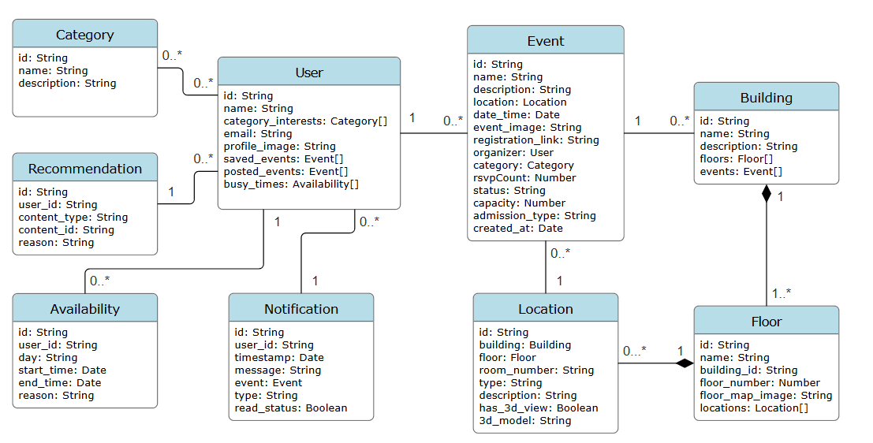

High-Level Sequence Diagrams

Explore All Events
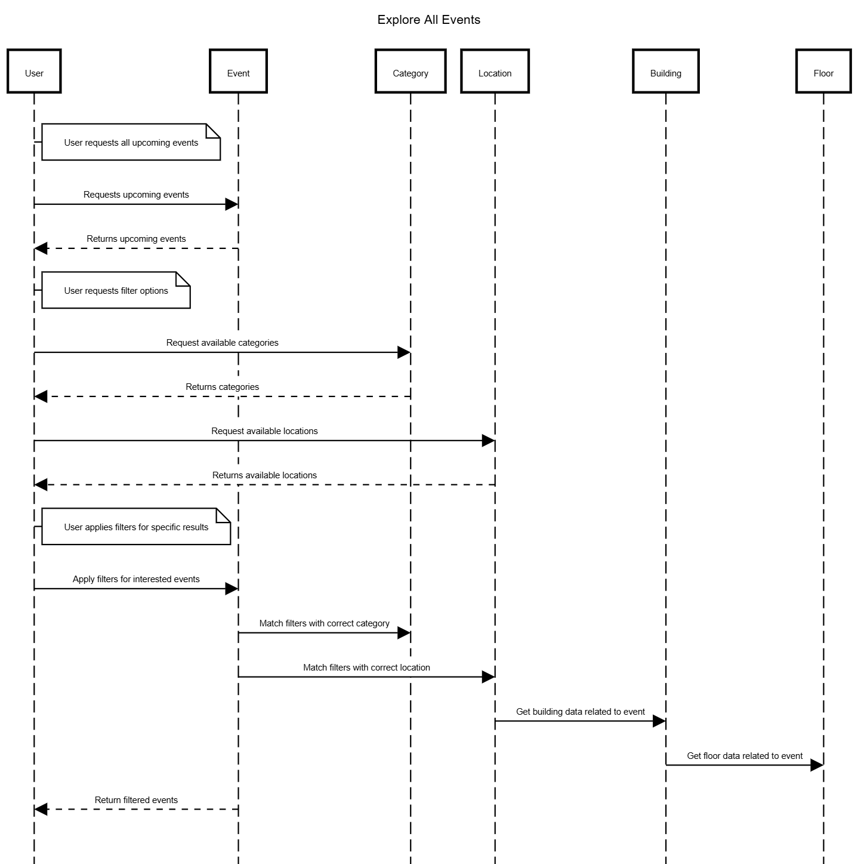

Recommended For You
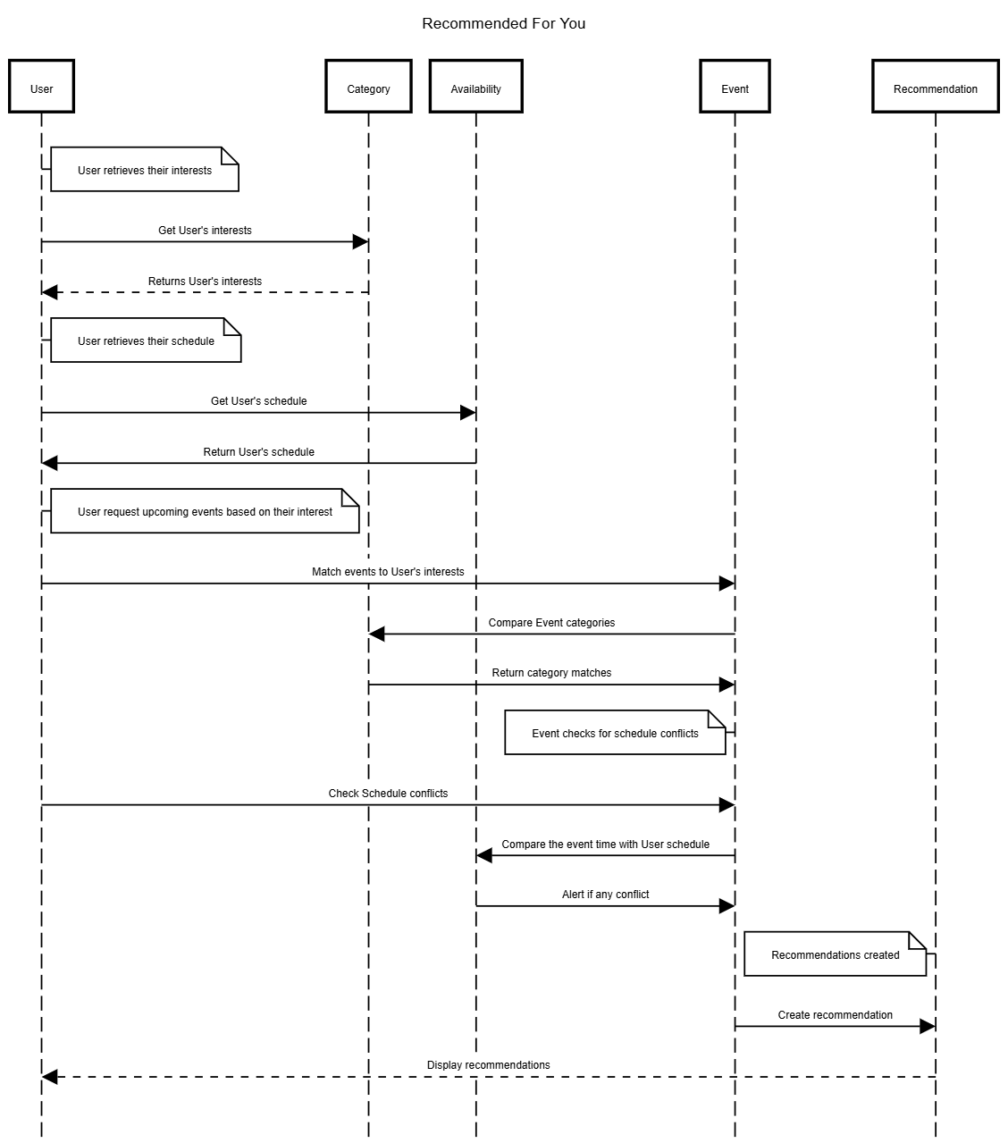

AI Schedule Scanner

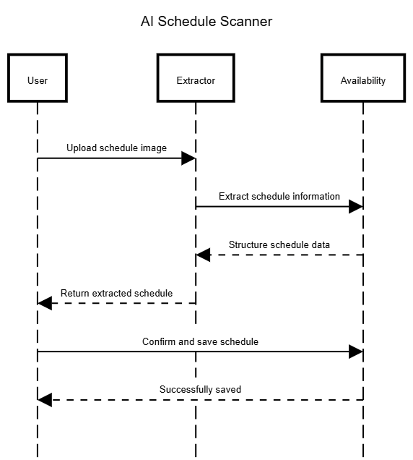

AI Assistant

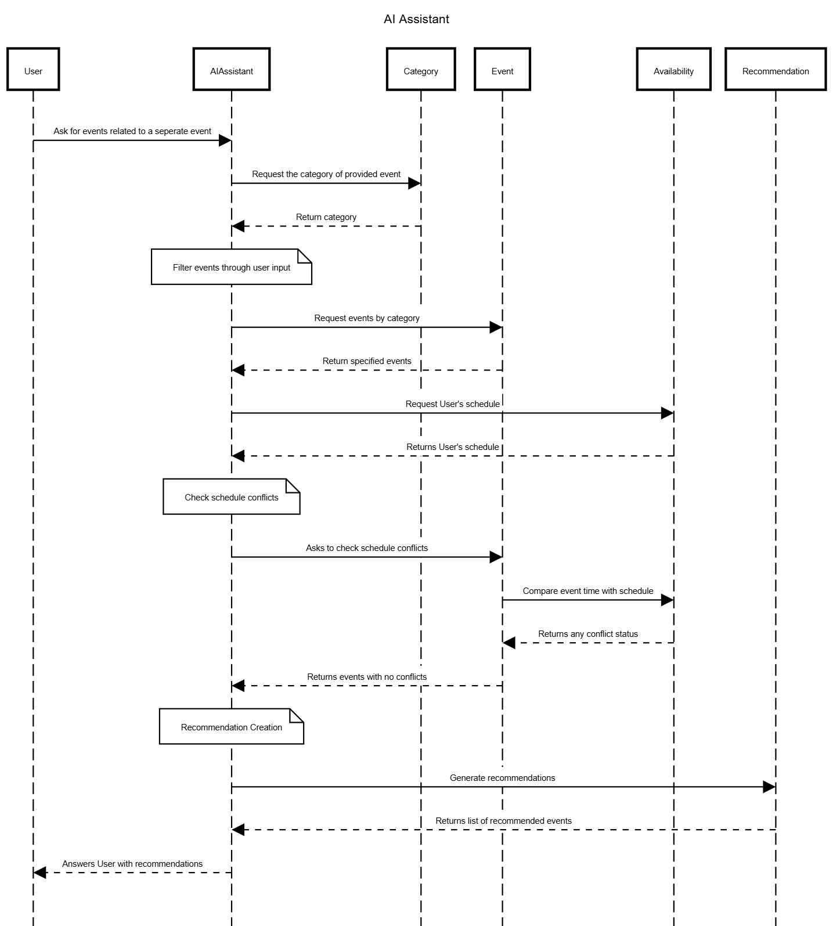

Interactive 2D Campus Map

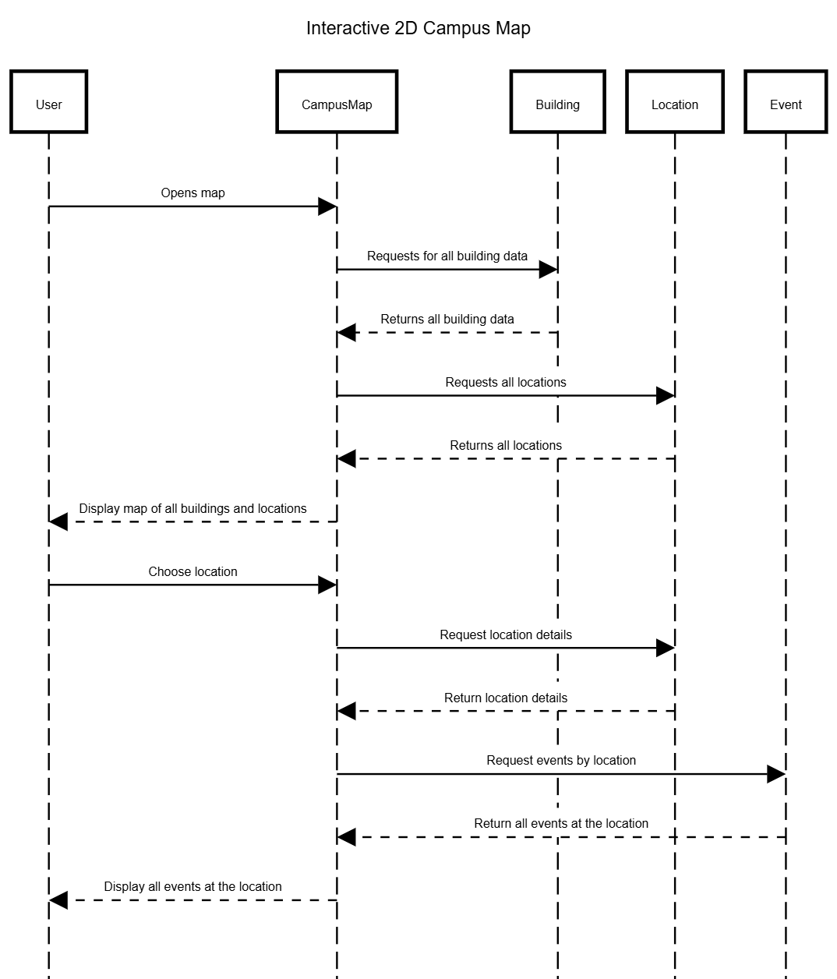

3D Campus & Event Exploration

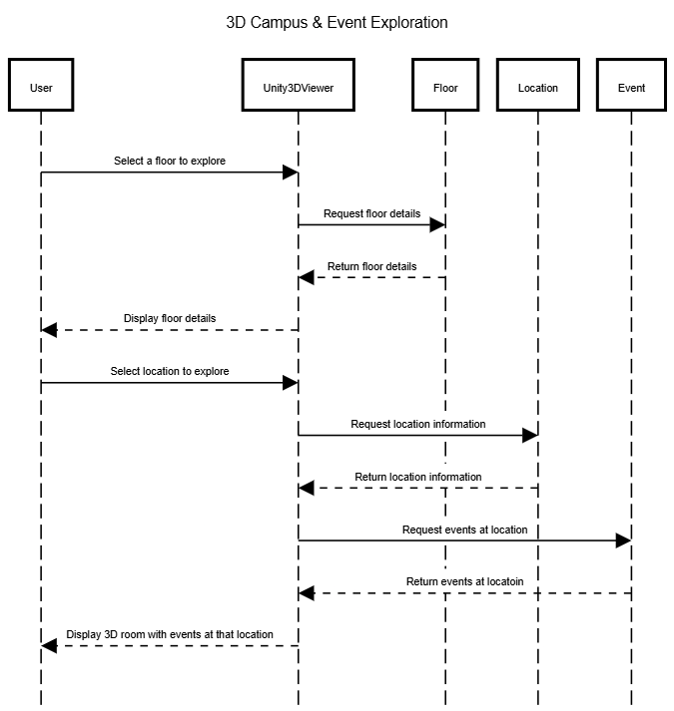

Project Status

Risks

Skills risks and mitigation plan: Our team has been following our study plan that covers all the technologies used in the project and every member has been following it. We don't see skills as a major risk, but we identified the following potential risks and how we address them.
- Risk 1: A team member may struggle to understand a technology or concept needed for their task, such as Next.js, Supabase or the database design.
  - Mitigation: Team members are encouraged to ask questions as soon as they come up, either in our Discord server or during our Scrum meetings. When someone finds a topic challenging, the teammate most familiar with it walks them through it. This way, everyone keeps learning and no one stays stuck for long.
- Risk 2: Knowledge of a feature may be concentrated in one person, which makes it harder for others to understand or support that part of the project.
  - Mitigation: We share knowledge openly through our study plan, Discord discussions and Scrum meetings, where members explain what they are working on. Helping each other is part of how our team works, so knowledge spreads naturally and more than one person understands each part of the application.

Schedule risks: Our team has a schedule in Jira that lists every member's detailed tasks. Each member knows exactly what they are responsible for and what is expected of them. Changes are shared with the team immediately, so the schedule stays transparent and up to date.
- Risk 3: A change to a task, such as a new requirement, a delay or a reassignment, could put other tasks or a project deadline at risk.
  - Mitigation: Any change is shared with the team right away and updated in Jira, so everyone can see the current status of every task. Since changes are communicated immediately, we can adjust quickly and keep up with our tasks and project deadlines.
- Risk 4: One team member's task may depend on another member's work. For example, a page may need a database table or an API endpoint to be finished first.
  - Mitigation: Dependencies between tasks are recorded in our Jira schedule and discussed during our Scrum meetings. Every member knows which tasks they are waiting on and which tasks depend on their work, so dependent work can be planned in the right order.

Teamwork risks: All members attend meetings regularly, keep their pace on assigned tasks, and ask for help when needed. Tasks are tracked in Jira. We do not see any risks regarding attendance or pace.
- Risk 5: A team member may occasionally be unable to attend a meeting because of a class, work or personal conflict, and miss decisions or updates.
  - Mitigation: Any member who can't attend lets the team know ahead of time in Discord. Meeting decisions and task updates are posted in Discord and reflected in Jira, so the member can catch up afterward. They also share their own progress in Discord, so the rest of the team stays informed.
- Risk 6: A team member may fall behind on a task. For example, during a busy week of exams or when a task turns out to be harder than expected.
  - Mitigation: We check progress during our Scrum meetings and through Jira, so a slowdown is noticed early. The member is encouraged to speak up as soon as they're behind, and teammates offer help or temporarily take on part of the work. If needed, we adjust the timeline in Jira so we still meet the project deadline.

Legal/content risks (can you obtain content/SW you need legally with proper licensing, copyright) How do you plan to resolve each problem Identify the risk and explain in 2-3 lines how you will address them
- Risk 7: Campus map data and SFSU sources
  - Description: The 2D Campus Map is drawn from OpenStreetMap (OSM) data. OSM's ODbL licence requires credit, and requires sharing any database we derive from it under the same licence. Building names, codes and rooms come from SFSU's public directories, and the official SFSU campus map was used only to check building names. Copying SFSU's map image or logo without permission would infringe their copyright.
  - Mitigation:
    - We show "© OpenStreetMap contributors" on the map.
    - Our generated map data (lib/map/geometry.js) is marked as ODbL-licensed and stays openly available in our repository.
    - We draw our own map from OSM data and never copy SFSU's map images or logos. Every location keeps a link to its official SFSU source.
- Risk 8: Room scans and software licences.
  - Description: 3D scans capture interiors of campus buildings, and the app relies on third-party software and services (Unity, Supabase, open-source libraries).
  - Mitigation:
    - We only scan public campus spaces, and will confirm with the instructor or the building's office before publishing any non-public room.
    - Unity is used under its free Personal licence, and all libraries we use are open source (MIT/ISC). We'll keep a licence list in the repo.
- Risk 9: AI processing of student schedules.
  - Description: The AI schedule scanner sends uploaded schedule images to Google Gemini. These images can contain personal data such as names, student IDs and class lists. On the free tier, Google's terms allow it to use submitted content to improve its products. AI results can also be wrong, for example a misread class time.
  - Mitigation:
    - The scanner will tell users their image is processed by Google AI, recommend cropping out personal details, and never store the image.
    - Users review and edit the extracted classes before saving.
    - The API key stays private on the server. The scanner will require sign-in, and we'll move to a paid tier, where data isn't used for training, if we deploy publicly.

